**YSD_B03_J2EE_Exam_SQL_Queries**

Name: Shadril Hassan Shifat, ID: 00-30135

1. **Write a query to find the average score for each assignment.**

SELECT assignments.assignment_id, assignments.assignment_name, avg(scores.score) AS average_score FROM scores

INNER JOIN assignments

ON assignments.assignment_id = scores.assignment_id

GROUP BY scores.assignment_id

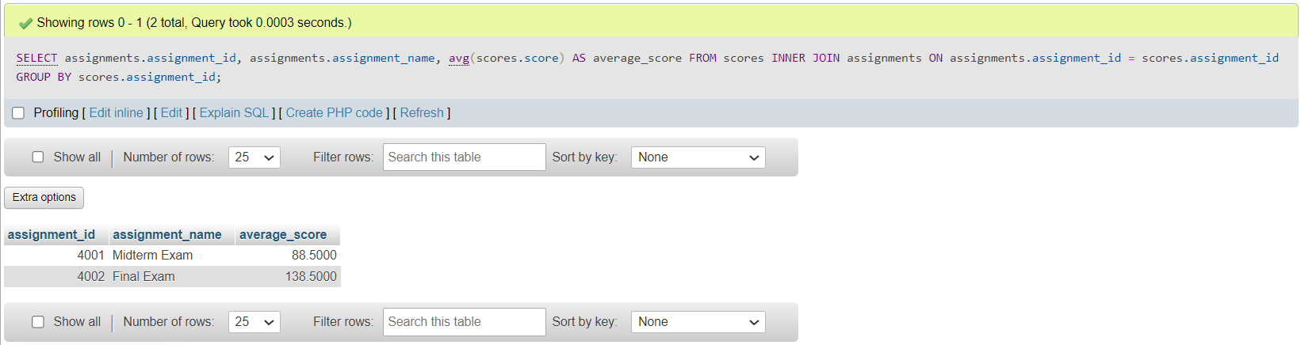

1. **Write a query to retrieve the student’s name, department, and total number of courses enrolled for students who have enrolled in more than 1 course.**

SELECT students.student_name, courses.department, COUNT(enrollments.enrollment_id) AS total_courses FROM enrollments

INNER JOIN students

ON students.student_id = enrollments.student_id

INNER JOIN courses

ON courses.course_id = enrollments.course_id

GROUP BY enrollments.student_id

HAVING COUNT(enrollments.enrollment_id) > 1

1. **Write a query to find the courses that have the highest enrollment count.**

SELECT courses.course_id, courses.course_name, COUNT(enrollments.enrollment_id) AS enrollment_count FROM enrollments

INNER JOIN courses

ON courses.course_id = enrollments.course_id

GROUP BY courses.course_id

ORDER BY enrollment_count DESC

LIMIT 1

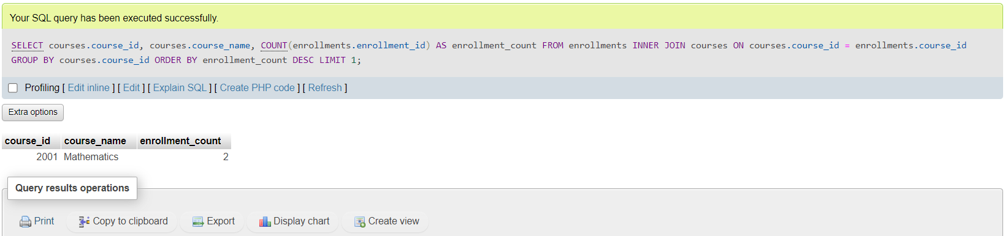

1. **Write a query to calculate the overall average score for each student.**

SELECT students.student_id, students.student_name, AVG(scores.score) AS average_score FROM scores

INNER JOIN students

ON scores.student_id = students.student_id

GROUP BY scores.student_id

1. **Write a query to find the students who have scored above the overall average score in all their assignments.**

SELECT students.student_id, students.student_name, scores.score FROM scores

INNER JOIN students

ON students.student_id = scores.student_id

WHERE scores.score > (SELECT AVG(scores.score) FROM scores)

